GenAI Retail Sales Analytics Chatbot
Comprehensive Business & Technical Documentation
This document provides a complete overview of the GenAI Retail Sales Analytics Chatbot, including business objectives, architecture, workflow, functional modules, supported analytics, testing strategy, and future enhancements.

1. Executive KPI Snapshot
The KPI dashboard summarizes the scale of the retail dataset and highlights the key metrics that business stakeholders monitor regularly.
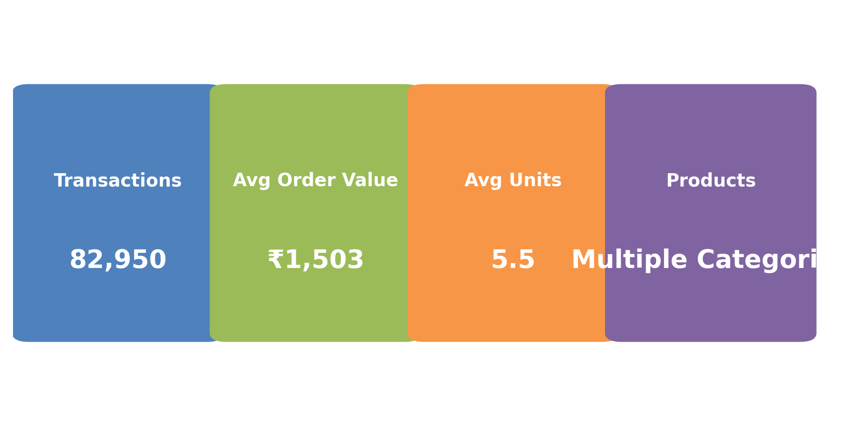

2. Solution Architecture
The architecture below shows how raw transactional data is transformed into conversational insights through a layered analytics and AI pipeline.
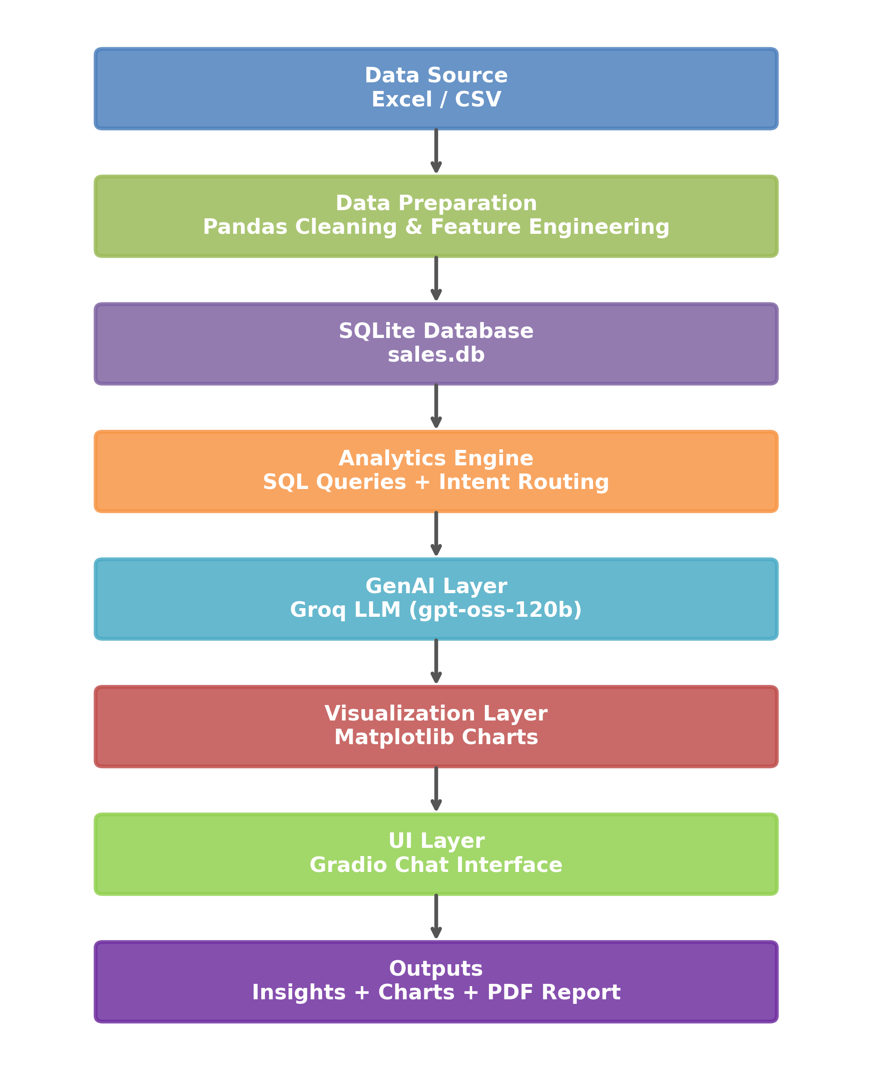

3. End-to-End Workflow
This workflow illustrates the sequence of steps executed from user question submission to insight generation and report export.
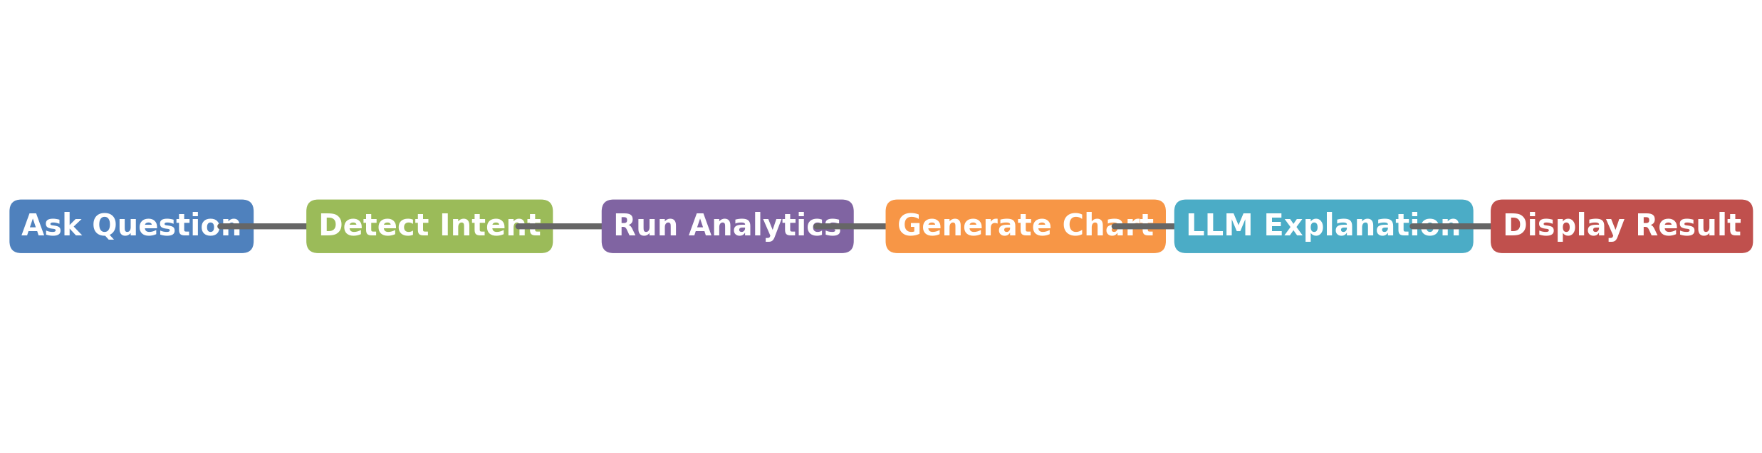

4. Executive Summary
The GenAI Retail Sales Analytics Chatbot empowers retail teams to ask natural language questions about sales performance and receive instant insights, charts, and downloadable reports. The solution combines Python-based analytics, SQLite, Groq LLM, and Gradio.
Users | Sales Managers, Analysts, Executives
Data Volume | 82,950 Transactions
Deployment Model | Single Jupyter Notebook
Outputs | Text Insights, Charts, PDF Reports

5. Business Objectives
- Democratize access to retail analytics for non-technical users.
- Reduce manual reporting effort.
- Accelerate decision-making on products and promotions.
- Provide executive-ready reports on demand.

6. Technology Stack
Layer | Technology
Programming Language | Python
Data Processing | Pandas
Database | SQLite
Visualization | Matplotlib
GenAI | Groq LLM (openai/gpt-oss-120b)
UI | Gradio
Reporting | ReportLab

7. Data Model
- Key source columns:
- transaction_id
- customer_number
- transaction_month
- product_name
- unit_price
- volume_units
- sales_amount
- promo_offer
- Derived columns:
- year
- month
- month_name
- year_month
- quarter

8. Functional Modules
- Data Preparation: Loads Excel/CSV data, cleans records, and creates derived columns.
- Intent Detection: Maps user questions to business intents.
- Analytics Engine: Executes SQL queries and aggregations.
- Visualization Engine: Generates charts for trend-based queries.
- LLM Explanation Engine: Converts numeric output into business narratives.
- UI Module: Provides a chat-based Gradio interface.
- Reporting Module: Exports conversations and charts to PDF.

9. Supported Analytics
- Total Sales
- Total Units Sold
- Average Order Value
- Monthly Sales Trend
- Best Sales Month
- Top Products
- Promotion Impact
- Top Customers
- Product Summary
- Product Comparison

10. User Interface Design
- Conversational chat window
- Suggested example questions
- Dynamic chart display
- Refresh Data button
- Generate PDF Report button
- Timestamp and response time metadata

11. Automation & Reporting
The Refresh Data button automatically reloads the source file, reprocesses the dataset, and rebuilds the SQLite database. The reporting module generates professional PDF reports containing all questions, answers, and charts.

12. Testing & Validation
Tested all the modules thoroughly end to end of lal the functional details.

13. UI/UX Feedback Summary
The Example data structure for feedback is also presented.

14. Business Benefits
- Faster access to insights
- Reduced dependency on technical teams
- Improved promotion and product decisions
- Executive-ready reporting

15. Future Enhancements
- Sales forecasting
- Natural Language to SQL
- KPI dashboard cards
- Role-based access control
- Cloud deployment

Conclusion
The GenAI Retail Sales Analytics Chatbot is a complete end-to-end solution that combines data engineering, business intelligence, generative AI, and intuitive UI design. It enables retail stakeholders to interact with data conversationally and make faster, better decisions.

Interactive UI Working video

https://drive.google.com/file/d/1KF1iHepB7BBkCHKjh2evFWFhchzkrfHW/view?usp=drive_link

